Your Full Portfolio Roadmap

October 2025 - May 2026

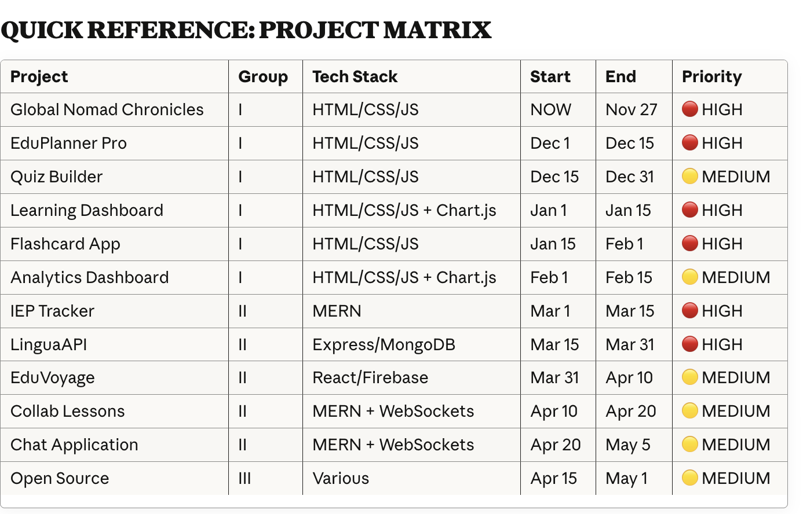

KEY MILESTONES
✅ November 27: Global Nomad Chronicles launched (Thanksgiving)
✅ December 31: 2 front-end projects complete
✅ February 15: 6 solid front-end projects complete + understanding backend concepts
✅ March 15: First fullstack project (IEP Tracker) live
✅ March 31: Two fullstack projects complete
✅ April 20: Four fullstack projects + WebSockets projects complete
✅ May 1: Portfolio complete with open source contributions
✅ May-June: Ready to start applying

NOTES
- These timelines assume 4-6 hours per day of focused coding work
- Adjust based on #100devs curriculum pace
- Some projects may take longer—that's okay, stay flexible
- Focus on quality over quantity—a polished project beats a rushed one
- Each project should be deployable and live before moving to the next
- Save your best project (Global Nomad or IEP Tracker) for your main portfolio showcase

PHASE 1: NOW THROUGH OCTOBER (HTML/CSS/JS Fundamentals)
Focus: Front-End Mastery & Design Thinking

PROJECT 1: ✅ Global Nomad Chronicles (Front-End Foundation)
Start Date: NOW (Content & Wireframes)
Target Completion: Thanksgiving (Late November)
Time Investment: 2-3 weeks of focused work
Project Synopsis: A full MERN blog platform showcasing your international teaching journey across Korea, Saudi Arabia, and the United States. Features rich storytelling, interactive location-based navigation, image galleries with lightbox effects, and a contact form. Your signature piece that demonstrates both technical skill and personal narrative. Emphasizes responsive design, accessibility, and polished user experience.
What You Need to Do:
- Finalize wireframes for all pages (you have structure, just polish)
- Write remaining blog posts (aim for 5-8 solid stories from Korea/Saudi Arabia/US)
- Organize and optimize all images (compress, alt text, accessibility)
- Build out vanilla JS for interactivity:
  - Timeline/location navigation (interactive or scrollable)
  - Image gallery with lightbox
  - Contact form validation
  - Smooth scrolling, animations
- Ensure full responsiveness (mobile-first)
- Accessibility audit (WCAG compliance, semantic HTML, keyboard navigation)
- Deploy to GitHub Pages or Netlify
Skills Showcased: HTML structure, CSS Grid/Flexbox, vanilla JavaScript, responsive design, accessibility

PROJECT 2: ✅ EduPlanner Pro (Vanilla JS + CSS)
Start Date: Early December 2025
Target Completion: Mid-December 2025
Time Investment: 1-2 weeks
Project Synopsis: A drag-and-drop lesson planner for teachers to organize lessons by day/week/month with resource links and reminders. Teachers can easily create, edit, and manage their curriculum visually. Data persists locally so teachers can save and revisit their plans. Focuses on intuitive UX and smooth interactions that make lesson planning enjoyable rather than tedious.
What You Need to Do:
- Finalize wireframes (you have concept, refine visual design)
- Build HTML/CSS for:
  - Calendar/weekly/monthly views
  - Drag-and-drop UI (research Sortable.js or vanilla JS approach)
  - Resource link management
  - Reminders section
- Vanilla JavaScript for:
  - Drag-and-drop functionality
  - localStorage for data persistence (user can save lessons locally)
  - Add/edit/delete lessons
  - Filter by date/resource type
- Polish design, make it beautiful (teachers will use this)
- Mobile responsive
- Deploy
Skills Showcased: DOM manipulation, event handling, localStorage, drag-and-drop, user experience design

PROJECT 3: Interactive Quiz/Assessment Builder
Start Date: Mid-December 2025
Target Completion: Late December 2025
Time Investment: 1.5-2 weeks
Project Synopsis: An interactive tool where educators create custom quizzes (multiple choice, true/false, short answer) and students take them with instant feedback and scoring. Teachers can build a quiz library, customize question types, and see results. Students get immediate scoring and can review answers. Demonstrates your ability to build complex user workflows and educational functionality that teachers actually need.
What You Need to Do:
- Wireframe: Quiz builder interface + quiz taker interface
- Build HTML/CSS for:
  - Form to create quizzes (multiple choice, true/false, short answer)
  - Quiz display/taking interface
  - Results/scoring display
- Vanilla JavaScript for:
  - Dynamic form inputs (add/remove question fields)
  - Quiz logic (scoring, answer checking)
  - Results calculation and display
  - localStorage to save quizzes
- User experience focus (make it intuitive)
- Deploy
Skills Showcased: Form handling, dynamic DOM creation, data logic, user workflow design

PROJECT 4: ✅ Accessible Learning Dashboard
Start Date: Early January
Target Completion: Mid-January
Time Investment: 1.5-2 weeks
Project Synopsis: A student progress tracking dashboard designed with accessibility as the foundation, not an afterthought. Teachers see student performance at a glance with clear visualizations, filters, and search. The entire interface is fully keyboard navigable, screen-reader compatible, and WCAG AA compliant. This is your showcase for understanding that good design means inclusive design. Employers in EdTech and accessibility-focused companies take notice of this.
What You Need to Do:
- Wireframe: Dashboard layout showing student data
- Build HTML/CSS for:
  - Student list/cards
  - Progress indicators (bars, percentages)
  - Filters and search
  - Responsive grid layout
- Vanilla JavaScript for:
  - Filtering/sorting student data
  - Dynamic progress updates
  - Chart.js integration for visualizations
- HEAVY accessibility focus:
  - WCAG AA compliance
  - Keyboard navigation (tab through all elements)
  - Screen reader tested
  - High contrast options
  - Semantic HTML
- This is your accessibility showcase project
- Deploy
Skills Showcased: Accessibility best practices, semantic HTML, data visualization, inclusive design

PROJECT 5: ✅ Language Learning Flashcard App
Start Date: Mid-January
Target Completion: Early February
Time Investment: 1.5-2 weeks
Project Synopsis: A spaced repetition flashcard app where language learners study vocabulary and grammar concepts. Features beautiful card flip animations, deck management, progress tracking, and light/dark mode. Users can create custom decks, study at their own pace, and watch their progress grow. Demonstrates your understanding of learning psychology, smooth animations, and creating apps people want to use repeatedly.
What You Need to Do:
- Wireframe: Card UI, deck management, learning interface
- Build HTML/CSS for:
  - Flashcard display (flip animation with CSS)
  - Deck selection/management
  - Progress tracker
  - Settings (light/dark mode, language pairs)
- Vanilla JavaScript for:
  - Flip animation on click
  - Spaced repetition logic (basic)
  - localStorage to save decks and progress
  - Add new cards/decks
- Polish interactions (smooth, satisfying UX)
- Deploy
Skills Showcased: CSS animations, JavaScript logic, learning app design, localStorage management

PROJECT 6: ✅ Classroom Analytics Dashboard (With Chart.js)
Start Date: Early February
Target Completion: Mid-February
Time Investment: 1.5-2 weeks
Project Synopsis: A comprehensive analytics dashboard that visualizes classroom data in multiple formats: bar charts for student performance by subject, line charts for progress trends over time, and pie charts for class distributions. Teachers can filter data, drill down into specifics, and understand their class at a glance. Demonstrates your ability to work with external charting libraries, handle data visualization, and create professional-looking analytical tools.
What You Need to Do:
- Wireframe: Dashboard showing student metrics, class trends
- Build HTML/CSS for dashboard layout
- Vanilla JavaScript + Chart.js for:
  - Bar charts (student performance by subject)
  - Line charts (progress over time)
  - Pie charts (class distribution)
  - Dynamic data filtering
- localStorage for sample data (or fetch mock API data)
- Responsive, professional design
- Deploy
Skills Showcased: Working with external libraries, data visualization, responsive design

PHASE 2: LATE JANUARY THROUGH FEBRUARY (Transition to Backend)
Focus: Learning Node/Express/MongoDB as #100devs teaches it
During this time:
- You'll be learning Express basics, REST APIs, MongoDB fundamentals
- Continue #100devs curriculum
- Don't start major coding projects yet—focus on understanding backend concepts through bootcamp assignments

PHASE 3: MARCH (MERN Stack Projects)
Focus: Full-Stack Power

PROJECT 7: ✅ IEP Tracker (Your First MERN App)
Start Date: Early March
Target Completion: Mid-March
Time Investment: 2-3 weeks
Project Synopsis: A full-stack MERN application designed specifically for special education teachers to manage and track IEP (Individualized Education Plan) progress. Teachers log student goals, track progress over time, and generate reports. Features secure authentication, role-based access (only authorized teachers can see their students), and dynamic progress charts. This is your most technically sophisticated project showing you understand building for a specialized, real-world use case with data security and compliance in mind.
What You Need to Do:
- Finalize wireframes (you have concept, refine)
- Backend (Node/Express/MongoDB):
  - User authentication with JWT
  - IEP data schema (student info, goals, progress)
  - CRUD endpoints for IEP records
  - Secure routes (only teachers can access their students' data)
- Frontend (React):
  - Login/authentication
  - Dashboard showing student IEPs
  - Form to create/edit IEP records
  - Progress tracking with Chart.js
  - Report generation (download PDF)
- Data security focus (sensitive student data)
- Deploy (backend on Heroku/Railway, frontend on Netlify)
Skills Showcased: Full MERN stack, authentication, data security, specialized use case (SPED)

PROJECT 8: ✅ LinguaAPI (Backend Mastery)
Start Date: Mid-March
Target Completion: Late March
Time Investment: 1.5-2 weeks
Project Synopsis: A RESTful API backend for language learners with comprehensive endpoints for vocabulary, grammar lessons, and interactive quizzes. Includes JWT-based authentication for user tracking, MongoDB storage, and full Swagger documentation. Users can track their learning progress, access lessons, and take quizzes. This showcases your backend architecture skills, API design, and ability to create well-documented, production-ready services that frontends can consume.
What You Need to Do:
- Finalize wireframes/API design
- Build Express/Node backend:
  - JWT authentication
  - MongoDB schema for vocab, grammar, quizzes
  - RESTful endpoints (GET, POST, PUT, DELETE)
  - Swagger documentation for API
  - Error handling and validation
- Test API endpoints (Postman)
- Deploy API (Heroku/Railway)
- Optional: Build simple React frontend to consume it
Skills Showcased: REST API design, backend architecture, authentication, documentation (Swagger)

PROJECT 9: ✅ EduVoyage (PWA + Firebase)
Start Date: Late March
Target Completion: Early April
Time Investment: 2-3 weeks
Project Synopsis: A mobile-friendly PWA where educators share travel journals from their international experiences, tag locations with geolocation, upload photos, and build a community of global educators. Features social elements (follow, like, comment), offline capability, and installable app experience. Demonstrates modern web technologies, real-time databases, and understanding of how teachers connect and share knowledge.
What You Need to Do:
- Finalize wireframes
- React frontend:
  - Geolocation to capture travel locations
  - Story/journal creation and editing
  - Photo upload and gallery
  - Social features (follow other educators, like stories)
  - User profiles
- Firebase backend:
  - Authentication
  - Firestore database
  - Cloud Storage for images
  - Real-time updates
- PWA features:
  - Service workers
  - Offline capability
  - Installable
- Deploy to Firebase Hosting
Skills Showcased: React, Firebase, PWA, geolocation API, real-time databases

PROJECT 10: ✅ Real-time Collaborative Lesson Planning Hub (Advanced MERN)
Start Date: Early April
Target Completion: Mid-April
Time Investment: 2-3 weeks
Project Synopsis: An advanced full-stack MERN application with WebSocket functionality allowing multiple teachers to collaboratively edit and plan lessons in real-time. Teachers can create lesson templates, draft lessons together, comment on plans, and track version history. When one teacher updates a lesson, all connected teachers see changes instantly. This is your most technically sophisticated project showcasing real-time collaboration, WebSockets, complex state management, and scaling for concurrent users.
What You Need to Do:
- Finalize wireframes
- Full MERN with WebSockets:
  - Multiple teachers can edit lessons simultaneously
  - Real-time sync with Socket.io
  - User authentication
  - Lesson templates and drafts
  - Version history
- Deploy
Skills Showcased: Advanced real-time collaboration, WebSockets, complex state management

PROJECT 11: Real-time Chat Application (MERN)
Start Date: Mid-April
Target Completion: Late April
Time Investment: 1.5-2 weeks
Project Synopsis: A multi-user chat application where users can create rooms, send messages in real-time, and manage user profiles. Features room management, message history, typing indicators, and user presence (who's online). Demonstrates your ability to build real-time applications, handle WebSockets, manage persistent data, and create smooth communication interfaces. This showcases backend logic, database design, and frontend state management all working together.
What You Need to Do:
- Finalize wireframes
- Backend (Node/Express/MongoDB):
  - User authentication with JWT
  - Room creation and management
  - Message storage and retrieval
  - WebSocket integration with Socket.io
  - User presence tracking
- Frontend (React):
  - Room list and selection
  - Message display and input
  - User list showing who's online
  - Typing indicators
  - Message notifications
- Deploy
Skills Showcased: WebSockets, real-time communication, backend/frontend sync, database design

PHASE 4: APRIL (Open Source + Polish)

✅ OPEN SOURCE CONTRIBUTIONS (Group III: 3-4 contributions)
Start Date: Mid-April
Target Completion: Late April
Time Investment: 3-5 hours per contribution
Project Synopsis: Contribute to established, well-known open source projects to demonstrate you can read others' code, work collaboratively, and add real value to larger codebases. Your contributions show employers you're a team player, understand version control, can follow contribution guidelines, and care about the open source community. Employers love seeing this on resumes.
Choose from these projects:
- freeCodeCamp – Education-focused, very hireable
  - Improve curriculum content
  - Fix bugs in their codebase
  - Add new features
  - Project Synopsis: Contribute to one of the largest free coding education platforms in the world. Show you understand education and can help others learn to code.
- Accessibility Libraries (axe-core, WCAG tools, Lighthouse)
  - Contribute to accessibility improvements
  - Write tests
  - Improve documentation
  - Project Synopsis: Help make the web more accessible for everyone. Demonstrates your commitment to inclusive design and real-world impact.
- MDN Web Docs
  - Write/edit documentation
  - Add code examples
  - Fix broken links
  - Project Synopsis: Contribute to the most trusted web development resource. Show you can communicate technical concepts clearly.
- Khan Academy (educational tech)
  - Documentation improvements
  - Bug fixes
  - Feature enhancements
  - Project Synopsis: Contribute to a platform teaching millions of students worldwide. Direct alignment with your teaching background.
What You Need to Do:
- Find 3-4 issues marked "good first issue" or "help wanted"
- Fork repo, create branch, make contributions
- Submit pull requests
- Engage with maintainers during review
- Get contributions merged
- Document your contributions on your portfolio
Skills Showcased: Collaboration, reading others' code, open source etiquette, Git workflow, community contribution

FINAL POLISH (Mid-April)

Before Graduation (Late March/Early April):
- All 10 projects deployed and live
- GitHub repos cleaned up with good READMEs
- All projects linked from a central portfolio page
- Each project has a description of what you built and why
- Screenshots/demos of each project

Before Job Hunting (May/June):
- Update resume with all projects
- Prepare 2-3 minute pitch for each major project
- Create demo videos if possible
- Get feedback on portfolio from peers/mentors
- Polish LinkedIn profile

